**A PROJECT REPORT ON**

**Vocal Mail: An Accessible Email System for the Visually Impaired**

SUBMITTED TO THE SAVITRIBAI PHULE PUNE UNIVERSITY, PUNE IN THE PARTIAL FULFILLMENT OF THE REQUIREMENTS FOR THE AWARD OF THE DEGREE

Of

**BACHELOR OF ENGINEERING**

IN (INFORMATION TECHNOLOGY)

**SUBMITED BY**

**Ms.Anushka Jadhav Exam No: B1904308517**

**Mr. Shravankumar Rakhunde Exam No: B1904308553**

**Ms.Nandini Rawool Exam No: B1904308554**

**Mr. Jayesh Sasane Exam No: B1904308556**

Under The Guidance of

**Prof.Nilesh Gunaware**



**DEPARTMENT OF INFORMATION TECHNOLOGY**

**STES’S SINHGAD ACADEMY OF ENGINEERING KONDHWA BK, PUNE 411048**

**SAVITRIBAI PHULE PUNE UNIVERSITY AY 2024 -2025**



**CERTIFICATE**

This is to certify that the Project Entitled

“**Vocal Mail: An Accessible Email System for the Visually Impaired**”

Submitted by

**Ms.Anushka Jadhav Exam No: B1904308517**

**Mr. Shravankumar Rakhunde Exam No: B1904308553**

**Ms.Nandini Rawool Exam No: B1904308554**

**Mr. Jayesh Sasane Exam No: B1904308556**

is a bonafide work has been carried out by them under the supervision of **Prof.Nilesh Gunaware** and it is approved for the partial fulfillment of the requirement of Savitribai Phule Pune University, for the award of the degree of **Bachelor of Engineering** (INFORMATION TECHNOLOGY).

**Prof.Nilesh Gunaware Dr. S. S. Kulkarni**

**Guide &Internal Examiner Head of Department**

(Name and Sign) **Dr .K .P .Patil**

**External Examiner Principal**

**Place: Pune**

**Date: / /2024**

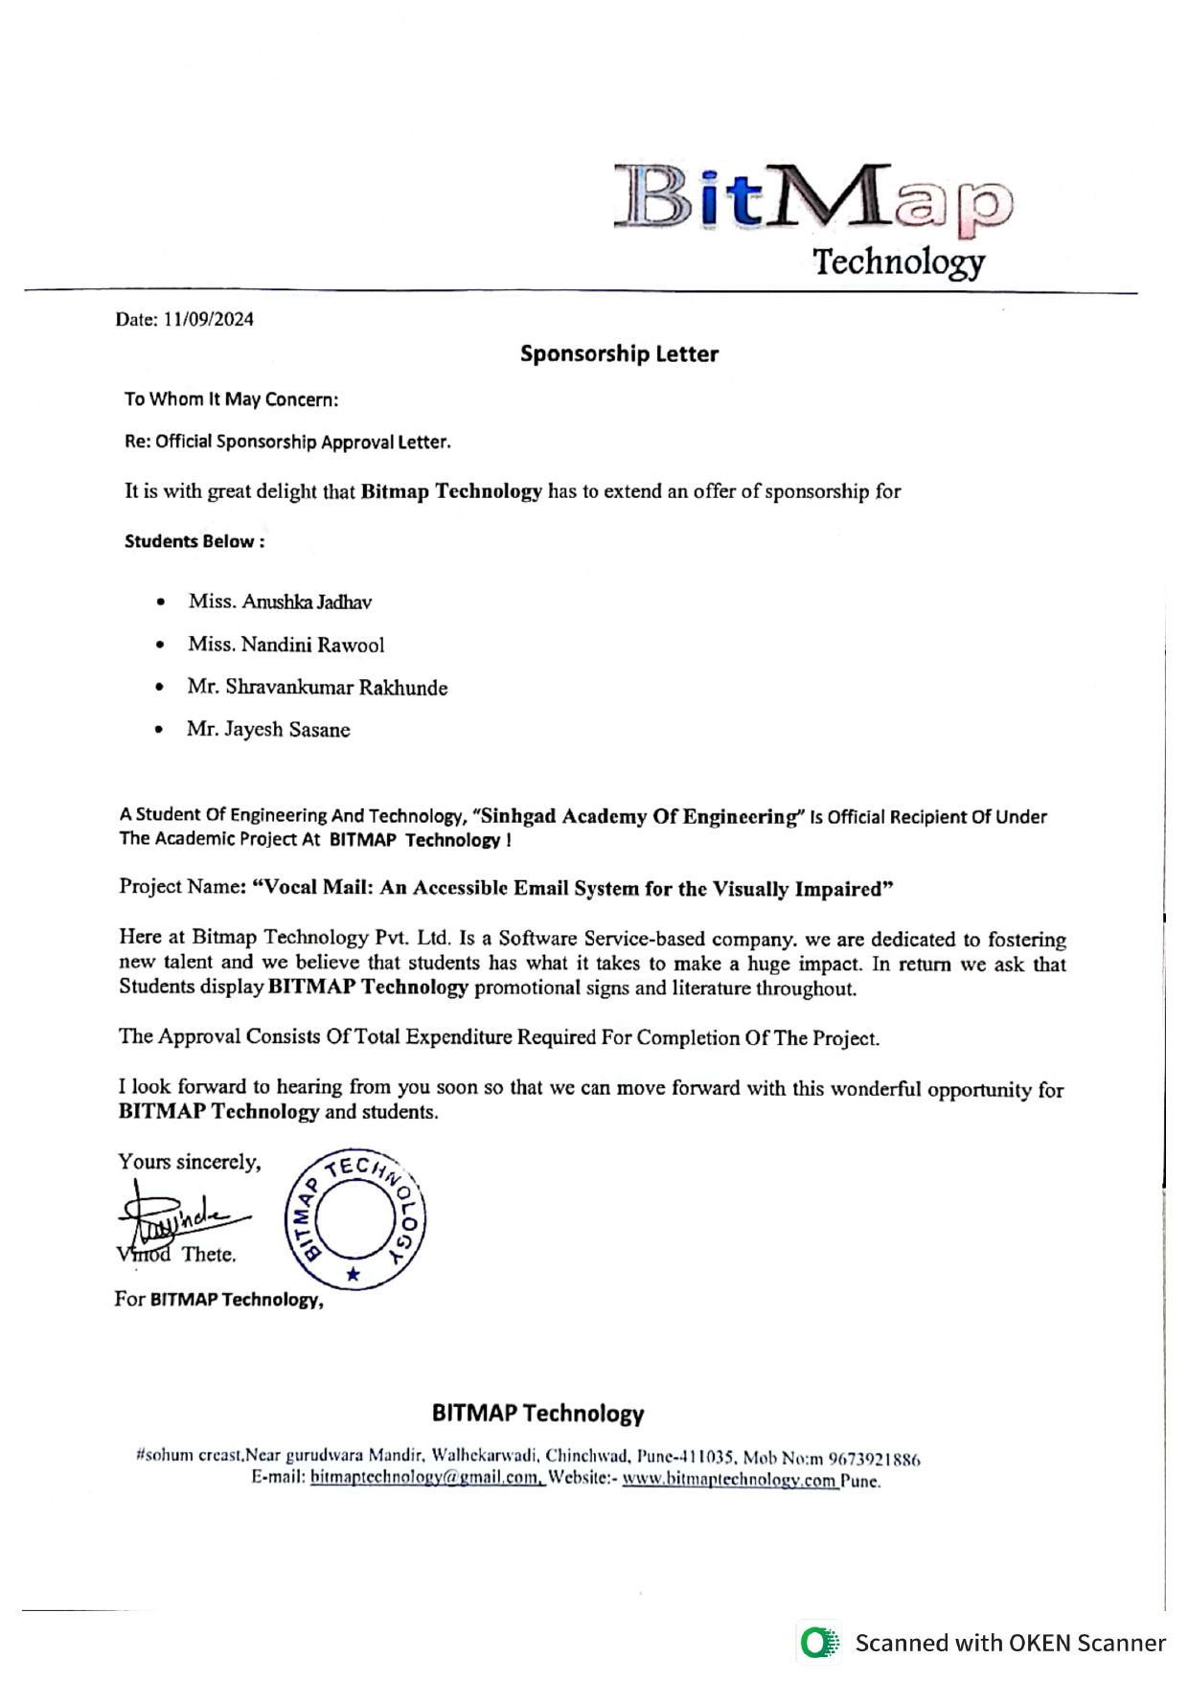

## Acknowledgment

We would like to extend our heartfelt gratitude to **Prof. Nilesh Gunaware** for his invaluable guidance, sharing his deep knowledge and experience, which has been instrumental in the completion of our report on “Vocal Mail: An Accessible Email System for the Visually Impaired.” His support has been a cornerstone in shaping this project.

Our sincere thanks go to **Dr. S. S. Kulkarni**, Head of the Department of Information Technology, for his encouragement, leadership, and ongoing support throughout the development of this system.

We also express our heartfelt gratitude to **Dr. Sunil L. Bangare**, our project reviewer, for his valuable feedback and constructive insights, which greatly enhanced the quality of our work.

We are deeply grateful to our dedicated faculty members, whose inspiration and support have driven us throughout the completion of this project.

This acknowledgment would be incomplete without expressing our appreciation to our respected **Principal**, the management, lab assistants, friends, and family. Their invaluable support has been crucial in the successful completion of this project as part of our curriculum.

Finally, we extend our sincere gratitude to the cooperative department for their unwavering assistance and for providing the necessary resources for this presentation.

## Abstract

In the present scenario, everybody needs communication technology to connect with each other. Communication technologies are significant these days for the betterment of social and personal interaction. The combination of technologies with the internet makes communication easy. However, the person who is physically challenged suffered a lot to utilize this technology due to visual and physical difficulties. There are many technologies advancements have come though it is not possible to use like normal users. This paper aims at creating an email system that helps even new users or physically impaired people to use the system for communication without any previous practices. There is no use of keywords, only with the help of mouse actions and voice conversion the email system works. The person who is not literate can also send emails as it is based on speech recognition and text to speech. The system is completely based on responsive voice interaction to utilize the technology easy and hassle-free manner. The system is well designed to send the mails quickly. There are all the options available to send emails and perform all the functions for the email system.

# INDEX

* **Certificate II**
* Sponsorship Letter III
* Acknowledgment IV
* Abstract V
* List of Figures VIII

1. Introduction 1
   1. Basic Concept 1
      1. Need of Project 1
      2. Purpose of Study 2
2. Literature Survey 3
   1. Study Of Research Paper 3
3. Software Requirements Specification 5
   1. Project Scope 5
   2. Features 5
   3. Functional Requirements 5
      1. External Interface Requirements 6
   4. Non Functional Requirement 7
      1. Performance Requirements 7
      2. Safety Requirement 7
4. Proposed System Architecture 8
   1. Software Quality Attributes 8
   2. Software Description 9
5. High Level Design 10
   1. DFD’s (Up To Level 2) 10
   2. UML Diagrams 12
      1. Use-Case Diagram 12
      2. Class Diagram 13
      3. Sequence Diagram 15
      4. Activity Diagram 17

* 1. Algorithm 18
  2. Methodologies 19

1. Planning and Scheduling 21
2. Conclusion  22
3. References 23

## List of Figures

* 1. Proposed System Architecture 8
  2. DFD Level– 0 10
  3. DFD Level– 1 10
  4. DFD Level – 2 11
  5. Use-Case Diagram 12
  6. Class Diagram 14
  7. Sequence Diagram 16
  8. Activity Diagram 17

# CHAPTER 1

# INTRODUCTION

### BASIC CONCEPT

The primary objective of this project is to create an accessible voice-based email system for visually impaired individuals & physically challenged, allowing them to interact with emails efficiently through voice commands. Traditional email systems rely heavily on graphical interfaces, which pose significant challenges for people with impaired vision. This system addresses those challenges by incorporating speech-to-text and text-to-speech technologies. Users can compose emails by dictating them, and the system converts their speech into text. Similarly, emails can be read aloud to the users using text-to-speech functionality, allowing them to listen to their messages. The system also uses interactive voice response (IVR) technology, simplifying the process of navigating different email functions like composing, reading, and managing messages. The user interface is designed to be minimal and intuitive, reducing complexity for visually impaired users. Additionally, the system includes secure login options using voice commands, ensuring both accessibility and privacy. By focusing on voice-based interaction, this project provides a solution that enables visually impaired individuals & physically challenged to use email without requiring visual assistance, promoting greater inclusivity in digital communication.

#### Need of Project

The need for this project stems from the critical challenges that visually impaired individuals face in accessing and using email systems, which are essential for modern communication. Traditional email interfaces rely heavily on visual elements, making them inaccessible without assistive technologies. This project aims to bridge the gap by developing a voice-based email system that allows users to compose, send, and receive emails using speech commands. Such a system would enhance digital inclusivity, improve accessibility, and empower visually impaired individuals to communicate independently and efficiently. It also addresses the need for user-friendly, secure, and accessible digital communication tools.

#### Purpose of Study

The purpose of this study is to develop an accessible email system that empowers visually impaired individuals to communicate digitally through voice commands, without the need for visual assistance. It aims to overcome the limitations of traditional email interfaces by using speech recognition and text-to-speech technologies, enabling users to send, receive, and manage emails seamlessly. This project seeks to enhance digital inclusivity, improve the independence of visually impaired users, and contribute to the development of user-friendly, accessible communication tools for all.

# CHAPTER 2

# LITERATURE SURVEY

### STUDY OF RESEARCH PAPER

### Voice-based email systems have become much more accessible for people with visual impairments due to new technology. Researchers have tried out different ways to make systems where people can send and receive emails just by talking. These systems use Speech-to-Text (STT), Text-to-Speech (TTS), and Natural Language Processing (NLP) to make it easier for everyone to use email, no matter what they can see.

Researchers (Rajput et al.)[2] have developed a user-friendly voice-based email system for people with visual impairments using AI and PyAudio. The system enables users to compose and send emails hands-free, using speech-to-text conversion. It also provides access to other services. AI-powered interfaces and NLP technologies allow the system to understand user commands and provide appropriate responses. This approach prioritizes ease of use, making the system accessible to individuals with technical limitations or vision issues.

Awasthi [3] and colleagues have developed a voice-activated email system aimed at making email accessible to visually impaired individuals. This system is designed to enhance the user experience by utilizing speech-to-text (STT) and text-to-speech (TTS) transformers, enabling users to manage their email using voice commands. The system eliminates the reliance on visual cues and keyboard navigation, addressing the challenges faced by visually impaired users, such as memorizing keyboard shortcuts and using mouse clicks. Instead, the voice-based system provides audio feedback and intuitive command responses, enhancing accessibility and ease of use.

Jain[1] and Suresh's[3] research aims to enhance the accuracy of voice-based email systems. They highlight the significance of Google's Text-to-Speech (gTTS) and speech recognition engines, enabling visually impaired individuals to access email effectively. Jain's system includes a user-friendly interface that accommodates both regular and visually impaired users, utilizing Python's speech recognition capabilities for voice input and standard email protocols (IMAP/SMTP) for email management.

Researchers Rajole and Phursule [1] identified that regular email systems often rely on visual displays, making them challenging for those with visual impairments. To address this issue, they developed a system that combines facial recognition for secure login and a voice-to-text feature that translates spoken commands into written text. This voice-activated system eliminates the need for manual interaction, allowing users to navigate email functions like inbox, sent items, and outbox solely through spoken commands.

In 2020, Sherly Noel developed a voice-controlled email application that uses human-computer interaction (HCI) to make it easier for visually impaired people to send and receive emails. This system gives users the ability to interact with their emails using voice commands, making it accessible to those who cannot use a graphical interface. Noel's system is a significant advancement in making technology more accessible to the visually impaired, highlighting the value of voice-based interactions in creating a positive user experience for this community.

While technology has made great strides, there are still challenges that need to be addressed. These include finding solutions for email attachments, improving the accuracy of speech recognition systems, and ensuring that these systems work with all assistive technologies. Additionally, even though these systems have shown to be beneficial for visually impaired users, ongoing testing, updates, and user training are essential to maintain and improve their effectiveness.

These systems promote inclusivity, but improvements are needed. Expanding language support and including features like file attachments and secure communication would enhance their accessibility. Wang et al. [2] suggest increasing security through hashing algorithms and better error-handling systems, leading to reduced errors and improved user experience.

# CHAPTER 3

# SOFTWARE REQUIREMENTS SPECIFICATION

### PROJECT SCOPE

The user only requires listening to the voice commands given by the system and re- spond accordingly in order to get the desired operations performed. This requires user to speak the operation in the email application and then the system will perform the required operations.

### FEATURES

* **Voice-Driven Interface**: The system relies on voice commands, allowing users to interact without using a keyboard. Users can dictate emails and navigate the system through speech.
* **Text-to-Speech and Speech-to-Text**: Emails can be read aloud to users, and users can compose messages by speaking, with the system converting their speech to text.
* **Interactive Voice Response (IVR)**: The system incorporates IVR for simplified navigation through different functions, making it easier to compose, read, and manage emails.
* **Secure Login with Voice Commands**: The system supports a secure, voice-activated login process, ensuring privacy and accessibility.
* **User-Friendly Design**: A minimal and intuitive interface is tailored to reduce complexity for visually impaired users, promoting easy and independent usage.
* **Enhanced Accessibility**: The system eliminates the need for visual assistance, making email communication accessible for visually impaired users, even those who are not familiar with traditional email interfaces.
* **Quick Email Sending**: The system is optimized for efficiency, allowing users to quickly send and manage emails without any visual components

#### FUNCTIONAL REQUIREMENTS System

**System Feature 1: Voice Interaction for Email Composition and Navigation**

* **Feature Point Extraction**:

The system detects and identifies key voice commands and specific phrases for email actions (e.g., compose, send, read) from the user's speech input.

* **Feature Correspondence Matching**:

The system matches identified voice commands with corresponding email functionalities. For example, commands like “compose mail” or “read inbox” are accurately mapped to relevant actions in the email system.

* **Point Estimation**:

The system uses speech recognition accuracy to estimate the user’s intent, ensuring the correct functionality is activated based on the user's spoken command.

#### External Interface Requirements

##### Software Requirements

* Operating System: Windows 10
* IDE: Pycharm ,Spyder
* Programming Language : Python

##### Hardware Requirements

#### User Interface

Application Based Smart E-Mail System For Blind People.

#### Hardware Interfaces:

* RAM : 8 GB
* As we are using Machine Learning Algorithm and Various High Level Libraries Laptop
* RAM minimum required is 8 GB. Hard Disk : 40 GB
  + Data Set of CT Scan images is to be used hence minimum 40 GB Hard Disk memory is required.
* Processor : Intel i5 Processor
  + Pycharm IDE that Integrated Development Environment is to be used and data load- ing should be fast hence Fast Processor is required
* IDE : Spyder is an open-source cross-platform integrated development environment for scientific programming in the Python language.
* Coding Language : Python Version 3.Highly specified Programming Language for Machine Learning because of avail- ability of High Performance Libraries.
* Operating System : Windows 10
  + Latest Operating System that supports all type of installation and development Environment.

### NON-FUNCTIONAL REQUIREMENT

##### Performance Requirements

The performance of the functions and every module must be well. The overall per- formance of the software will enable the users to work efficiently. Performance of encryption of data should be fast. Performance of the providing virtual environment should be fast Safety Requirement

•The application is designed in modules where errors can be detected easily. This makes it easier to install and update new functionality if required.

##### Safety Requirement

The application is designed in modules where errors can be detected and fixed easily. This makes it easier to install and update new functionality if required.

##### 3.4.3 Security Requirement

Use secure communication protocols to encrypt data transmitted between the user’s device and your servers, preventing interception by unauthorized parties. encrypt data stored on servers and databases to protect user information even when it’s not actively being transmitted.

##### CHAPTER 4

##### PROPOSED SYSTEM ARCHITECTURE

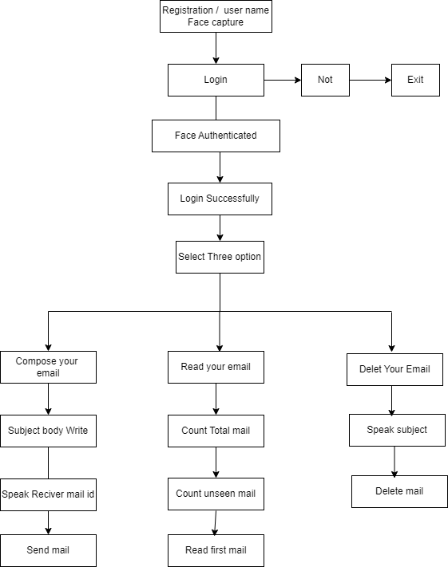

Document Attachment

Figure 4.1: Proposed System Architecture

### SOFTWARE QUALITY ATTRIBUTES

* Adaptability: This software is adaptable by all users.
* Availability: This software is freely available to all users. The availability of the software is easy for everyone.
* Maintainability: After the deployment of the project if any error occurs then it can be easily maintained by the software developer.
* Reliability: The performance of the software is better which will increase the reliability

of the Software.

* User Friendliness: Since, the software is a GUI application; the output generated is much user friendly in its behavior.
* Integrity: Integrity refers to the extent to which access to software or data by unauthorized persons can be controlled. 
* Security: Users are authenticated using many security phases so reliable security is provided.
* Testability: The software will be tested considering all the aspects.

### SOFTWARE DESCRIPTION

Coding Language Python is an excellent choice for a wide range of programming tasks, from web development to data analysis and scientific computing. It has a large and active community, which means plenty of libraries and resources are available Anaconda Navigator Anaconda is a free and open-source distribution of the Python and R programming languages for scientific computing (data science, machine learning applications, large-scale data processing, predictive analytic, etc.), that aims to simplify package management and deployment. The distribution includes data- science suitable for Windows, Linux, and mac OS. It is developed and maintained by Anaconda, Inc., which was founded by Peter Wang and Travis Antiphonal in 2012. As an Anaconda, Inc. product, it is also known as Anaconda Distribution or Anaconda Individual Edition ,while other products from the company are Anaconda Team Edition and Anaconda Enterprise Edition, both of which are not free IDE-Spyder Spider is a popular IDE for Python, particularly among data scientists and scientists. It offers features such as an interactive console, code editor, and integrated plotting and debugging tools, making it well-suited for scientific computing and data analysis tasks. Another popular Python IDE you might consider is PyCharm, which is known for its excellent code analysis and debugging capabilities. It’s suitable for both scientific computing and general purpose development.

# CHAPTER 5

# HIGH LEVEL DESIGN

##### 5.1 DFDS (UP TO LEVEL 2)

**DFD Level– 0**

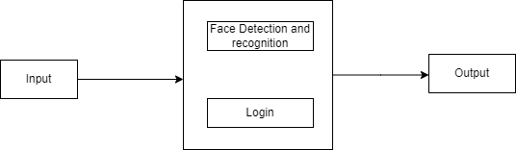

Figure 5.2: DFD Level– 0

##### DFD Level– 1

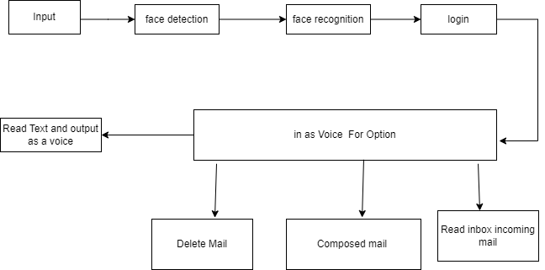

Figure 5.3: DFD Level– 1

##### DFD Level – 2

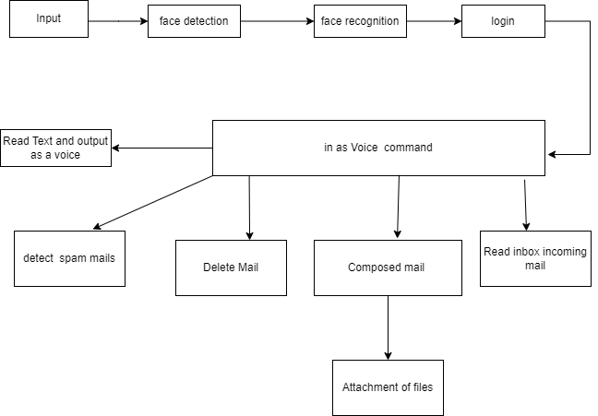

Figure 5.4: DFD Level – 2

### 5.2 UML DIAGRAMS

##### 5.2.1 Case Diagram

Use case illustrates a unit of functionality provided by the system. The main purpose of the use case diagram is to help development teams visualize the functional requirements of a system, including the relationship of “actors” to essential processes, as well as the relationships among different use cases. Use-case diagrams generally show groups of use cases, either all use cases for the complete system, or a breakout of a particular group of use cases with related functionality to Show a use case on a use-case diagram, you draw an oval in the middle of the diagram and put the name of the use case in the center of, or below, the oval. To draw an actor (indicating a system user) on a use-case diagram, you draw a stick person to the left or right of your diagram. Following diagram shows the relationships of the user or actors with the use cases which are shown in an oval shape.

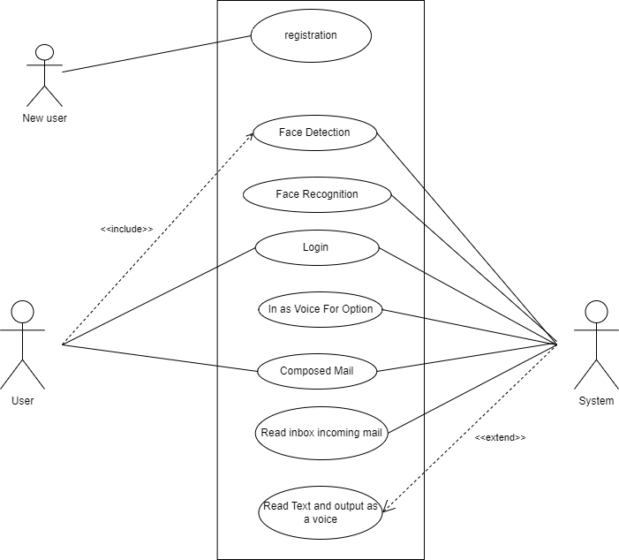

Figure 5.5 Use-case Diagram

**5.2.2 Class Diagram**

In software engineering, a class diagram in the Unified Modelling Language (UML) is a type of static structure diagram that describes the structure of a system by showing the system’s classes, their attributes, operations (or methods), and the relation- ships among objects.

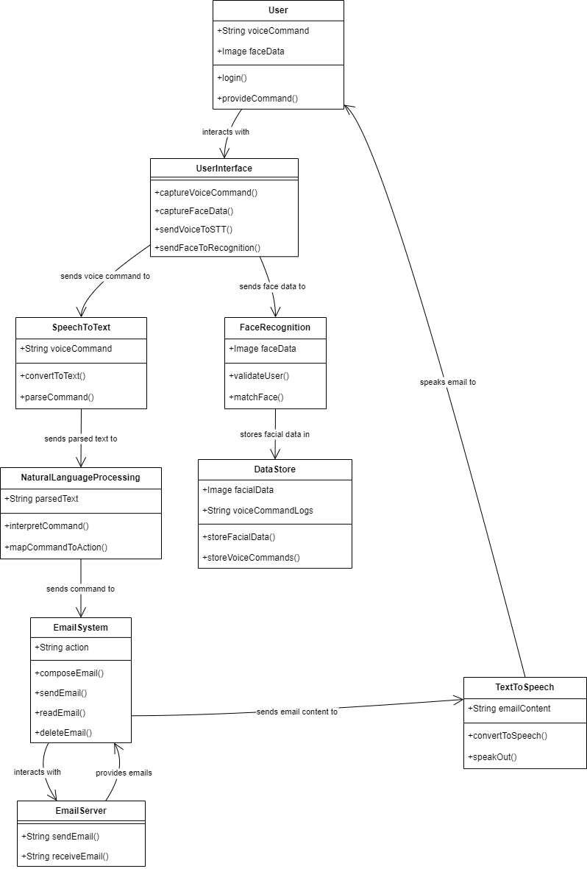

Figure 5.6: Class Diagram

#### 5.2.3 Sequence Diagram

Sequence diagrams can be used to explore the logic of a complex operation, function, or procedure. They are called sequence diagrams because sequential nature is shown via ordering of messages. First message starts at the top and the last message ends at bottom. The important aspect of a sequence diagram is that it is time-ordered. This means that the exact sequence of the interactions between the objects is represented step by step. Different objects in the sequence diagram interact with each other by passing “messages”. Above Sequence diagram shows that how the interaction between object is represented step by step.

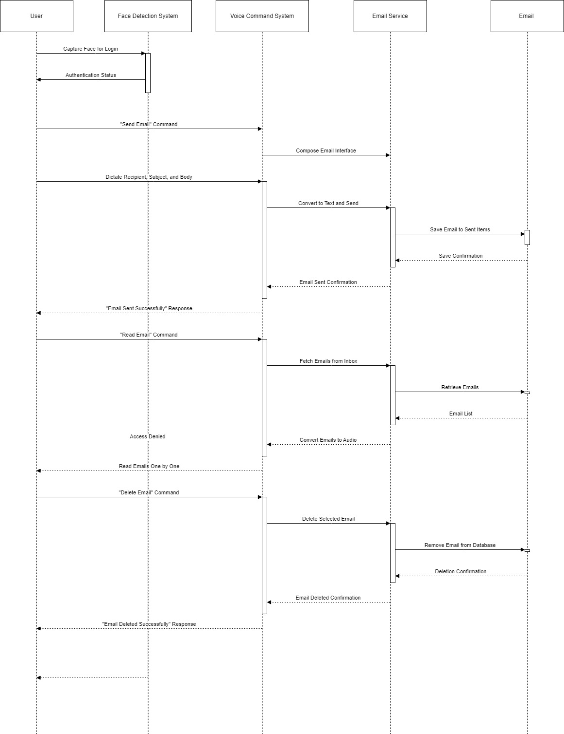

Figure 5.7: Sequence Diagram

#### Activity Diagram

Activity diagram is typically used for business process modelling, for modelling the logic captured by a single use case, or for visualizing the detailed logic of a business rule. Complicated process flows in the system are captured in the activity diagram. Similar to a state diagram, an activity diagram also consists of activities, actions, transitions, initial and final states, and guard conditions. However, difference is state diagrams are in context of simulation while activity gives detail view of business logic. Activity diagrams are “less technical” in appearance ,compared to sequence diagrams, and business-minded people tend to understand them more quickly

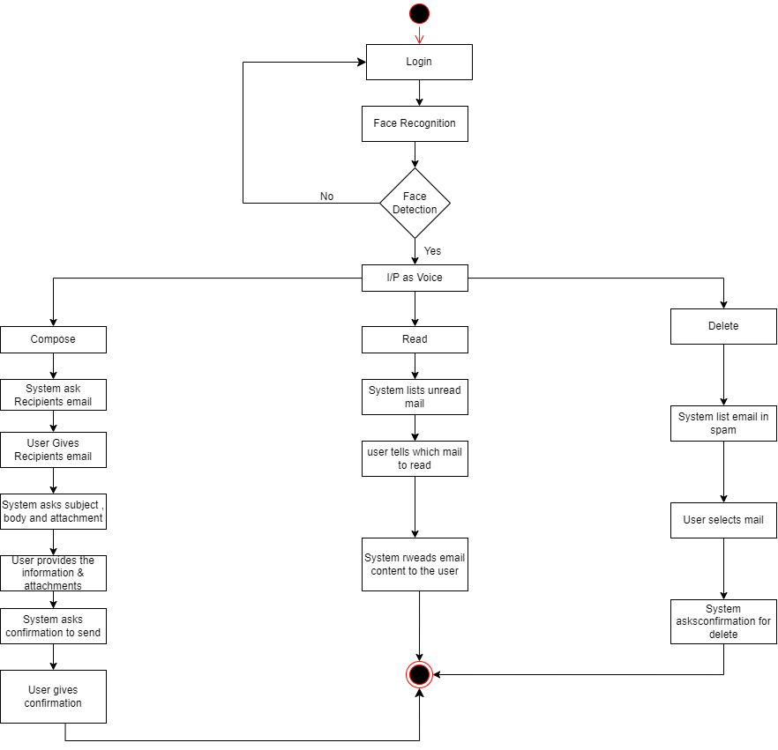

Figure 5.8: Activity Diagram

### ALGORITHM

### Haar Cascade

The Haar Cascade algorithm is a machine learning-based object detection method, widely used for tasks like face detection. It works by using Haar-like features, which are simple rectangular patterns that capture changes in pixel intensity, such as edges or lines, to identify objects. To speed up feature computation, it employs an integral image, which allows for quick summation of pixel values. The algorithm is trained with Adaboost, a technique that selects the most relevant features from a large set and builds a strong classifier from weak ones. Detection is performed in stages through a cascade of classifiers, where non-object regions are quickly rejected, making the method efficient and fast for real-time applications.

The Haar Cascade is particularly known for its use in face detection and is widely implemented in OpenCV, but it can also be trained to detect other objects like eyes or cars. Its advantages include being lightweight and fast, suitable for real-time applications, even with limited computational resources. However, it can struggle with detecting objects in complex scenes or non-frontal faces and is not as robust as modern deep learning methods like Convolutional Neural Networks (CNNs). Despite its limitations, it remains a foundational algorithm in computer vision due to its simplicity and efficiency.

**NLP:- Natural Language Processing:**

Natural Language Processing (NLP) is a field of artificial intelligence focused on the interaction between computers and human language. It involves developing algorithms and models that enable machines to understand, interpret, and generate human language in a way that is meaningful. NLP combines techniques from linguistics and computer science to analyze text or speech, enabling tasks such as language translation, sentiment analysis, speech recognition, and chatbots. Core components of NLP include text preprocessing (tokenization, stemming, lemmatization), syntactic analysis (parsing), semantic understanding, and machine learning models that can learn from large amounts of language data.

NLP has broad applications in modern technology, from virtual assistants like Siri and Alexa to automated customer service systems and advanced search engines. Deep learning models like Transformers (e.g., BERT, GPT) have significantly advanced NLP by enabling machines to capture the context and meaning of words in relation to each other, improving tasks like text generation and comprehension. Despite impressive progress, NLP still faces challenges such as understanding idiomatic expressions, cultural nuances, and generating truly human-like conversations, but ongoing advancements continue to push the boundaries of how machines understand and process language.

### METHODOLOGIES

A voice-based email system allows users to interact with their email using voice commands, eliminating the need for a graphical interface or typing. This system can be particularly useful for visually impaired individuals or in situations where hands-free operation is preferred. To develop such a system, several methodologies are typically involved, combining natural language processing (NLP), speech recognition, and email management technologies.

**1. Speech Recognition:**

Automatic Speech Recognition (ASR) is the core technology that converts spoken language into text. ASR systems like Google Speech-to-Text, Microsoft Azure Speech, or CMU Sphinx use deep learning models, particularly Hidden Markov Models (HMMs) or more recently, Recurrent Neural Networks (RNNs) and Transformer-based models, to recognize spoken words with high accuracy.

The ASR component listens to user commands, such as "send an email to John" or "read my latest email," and translates them into text input for the system.

**2. Natural Language Processing (NLP):**

NLP techniques are employed to understand and process the transcribed text from the speech recognizer. NLP tasks like intent recognition, entity extraction, and text classification help the system understand what the user wants to do (e.g., sending, reading, deleting an email). Popular models for NLP include BERT, GPT, or spaCy pipelines, which can classify commands and detect parameters like email recipients, subject lines, and message content.

Intent-based classification is used to distinguish between commands like reading, composing, or deleting emails, while Named Entity Recognition (NER) helps extract key details like the recipient's name or the content of the message.

**3. Text-to-Speech (TTS):**

Once the system processes the email action, it needs to communicate back to the user. Text-to-Speech (TTS) technology, which converts text data into spoken words, is used to read emails aloud or confirm actions. Modern TTS systems use deep learning models, such as WaveNet or Tacotron, to generate more natural and human-like speech.

This ensures that the system can not only listen but also respond to users in a clear and understandable voice, allowing for fluid interaction.

**4. Email Integration:**

The system integrates with email services (e.g., Gmail, Outlook) via their APIs to perform operations such as sending, receiving, and managing emails. This component interacts with the user's inbox, parses emails, and manages tasks like fetching messages or composing new ones based on voice commands.

Email parsing may involve NLP tasks like summarization to provide brief overviews of lengthy emails when reading them aloud.

**5. Command Management and Dialogue System:**

To make the system interactive, a dialogue management component is necessary to handle multiple rounds of conversation with the user. For example, if a user says, "Send an email to Sarah," the system may ask, "What should the subject be?" or "Do you want to add an attachment?" This requires maintaining context across the conversation, which is often handled using state machines or dialogue systems like Rasa or Dialogflow.

**6. Error Handling and Confirmation:**

Because voice recognition can sometimes misinterpret commands, a robust system must include error handling. This includes asking the user to confirm actions before they are executed (e.g., "Do you want to send this email?") and providing the option to cancel or correct any mistakes in real-time.

By combining these methodologies—speech recognition, NLP, text-to-speech, email integration, and dialogue management—a voice-based email system can provide an intuitive, hands-free way to manage email communication through voice commands.

# CHAPTER 6

# PLANNING AND SCHEDULING

|  |  |  |  |
| --- | --- | --- | --- |
| Month Scheduled | Phase | Name of Group Members | Work done |
| July | Topic searching | 5/07/2024 | Topic Searched |
|  | Topic selection | 18/07/2024 | Topic Selected |
|  | Project confirmation | 22/07/2024 | Project Confirmed |
| August | Review 1 | 2/08/2024 | Review 1 Done |
|  | Final Review 1 | 7/08/2024 | Final Review 1 Done |
| September | Requirement  Gathering | 03/09/2024 | Requirements  Gathered |
|  | Coding | 25/09/2024 | Coded Different modules |
| October | Review 2 | 15/10/2024 | Review 2 Done |

# CHAPTER 7

# CONCLUSION

The voice-based email system presented in this study is intended to improve accessibility for users who are blind or visually challenged. The system provides an effective and user-friendly interface for email management by fusing speech-to-text and text-to-speech technologies with face recognition for safe login. Utilizing datasets that have been specially trained guarantees privacy and lessens dependency on other providers. Future research will concentrate on enhancing the accuracy of speech recognition, increasing multilingual support, and incorporating attachment management.

# CHAPTER 8

# REFERENCES

[1] Conferencing, Paging, Voice Mailing via Asterisk PBX – Ale Imran and Mohammed A. Qadeer [2019]

[2] Finding with the design of a command- based speech interface for a voice mail system -S,Gamm and D.Langmann [2018]

[3] Design and implementation of voice mail in IP telephony based on Mediastreamer2- Xu Yue and Xu Bing[2021]

[4] On the integration of MPEG-4 video streams with voice and email data packet traffic over wireless picocell networks- P. Koutsakis, S. Psychic and M. Paterakis[2021]

[5] Performance analysis of Voice message service in CDMA cellular systems”- Song Liu, Zhisheng Niu and Dawei Huang [2020]

[6] Harivans Pratap Singh, Aman Pratap Kushwaha, Aayushmaan, Harendra Singh, “Voice-Based Email System”. International Journal of Innovative Science and Research TechnologyVolume 6, Issue 7, July – 2023

[7] Mullapudi Harshasri , Manyam Durga Bhavani , and Misra Ravikanth, “Voice Based Email for Blind”. - International Journal of Innovative Research in Computer Science & Technology (IJIRCST) ISSN: 2347-5552, Volume-9, Issue-4, July 2021